input.doc Name:_______________________

Below are some functions with their graphs. Determine whether the functions have any discontinuities within the interval shown. If so, where are the discontinuities and what type of discontinuities are they?

1) $g(x)=x^{2}−4x−3$ 2) $h(x)=\frac{x^{2}−4x−5}{x−5}$
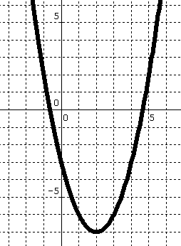
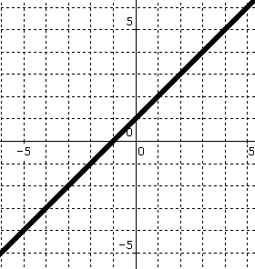

3) $j(x)=\frac{x^{2}−x}{x^{2}−9}$ 4) $k(x)=\begin{aligned}\left\{2x+4, x≤−1 | \right.\end{aligned}$
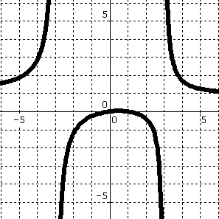
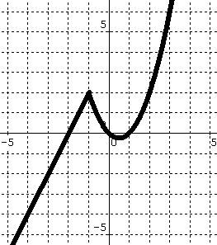

5) $m(x)=\begin{aligned}\left\{\frac{x−1}{x^{2}−\text{25}}, x<0 | \right.\end{aligned}$ 6) $f(x)=\frac{x+2}{x^{2}−4}$
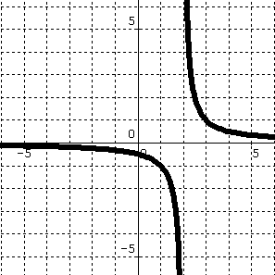
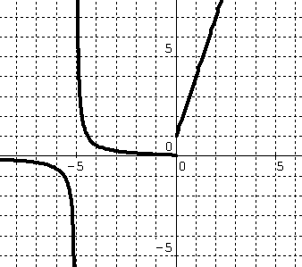

Determine algebraically whether the following functions are continuous. If not, explain why and indicate any points where the functions are NOT continuous.

7) $f(x)=\frac{x^{2}+2x}{x}$ 8) $f(x)=\frac{x^{2}+2x}{x^{2}+5x+6}$

9) $f(x)=\begin{aligned}\left\{3x^{2}−\text{20} (x≤3) | \right.\end{aligned}$ 10) $f(x)=\begin{aligned}\left\{x+7 (x≠−1) | \right.\end{aligned}$

11) $f(x)=\begin{aligned}\left\{\frac{\text{10}}{x−3} (x<2) | \right.\end{aligned}$ 12) $\begin{aligned} \\ f(x)=\begin{aligned}\left\{x−\text{12} (x<2) | \right.\end{aligned} \\ \end{aligned}$

13) $f(x)=\frac{x^{2}+2x}{2}$ 14) $f(x)=\frac{x^{5}−8x^{3}+x^{2}+6}{x−1}$

